**README for "Panda the friends bot”**

**Group Members:**

Hafsa khan (SP17-BCS-080)

Rabia Majeed (SP17-BCS-083)

**Introduction:**

Panda the friend’s bot is made with AIML on pandorabots. The aim of this bot is to interact with the user and answer their queries related friend’s season. It also recommend different seasons to user according to his/her choice.

**Libraries Installed:**

1. *pip install py2neo* for python and neo4j connection
2. *pip install numpy*
3. *pip install sklearn* for ML algorithms
4. *pip install pandas* for reading csv file
5. *pip install nltk* for NLP
6. *pip install aiml* for chatbot aiml files
7. *pip install python-aiml* for integration of AIML files with python
8. *react f*or chatbot gui
9. *npm*
10. *node*

**Tools Required:**

1. Visual Studio Code
2. Neo4j
3. Pandorabots
4. Python

**How to Run:**

1. First open Neo4j database and create a project and in the project create a graph.
2. Now run the graph
3. Open the main python file on VS Code and Run it.
4. Give your commands or queries for the bot.

**Gui:**

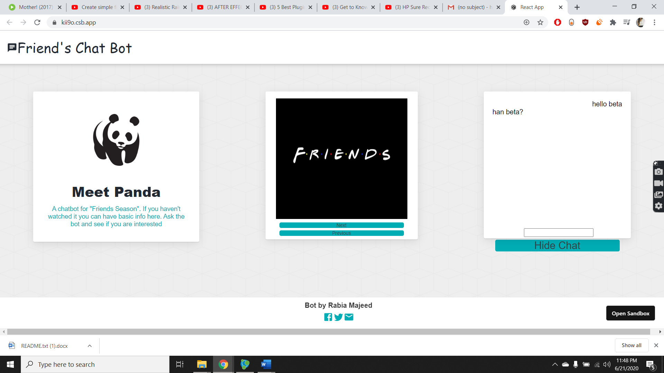

<https://kii9o.csb.app/>

<https://codesandbox.io/s/chat-bot-ui-8iyri>

**Author and Maintainer:**

Hafsa khan (SP17-BCS-080)

Rabia Majeed (SP17-BCS-083)

21 June 2020